TKTI MvaKT fakulteti “Xorijiy Tillar” kafedrasi professor -o‘qituvchilari tomonidan talabalar turar joyida davra suxbat
B A Yo N N O M A S I

26.05.2023 Toshkent shahri

QATNAShDILAR: “Xorijiy Tillar” kafedrasi professor -o‘qituvchilari va TTJ talabalari
KUN TARTIBI:
O’zbekiston Respublikasi Davlat ramzlari
TTJ talaba yoshlar yashash sharoitini o’rganish
Xorijiy tillar kafedrasi mudiri F.T.Sayfullayeva davlatimiz ramzlari va yoshlarimiz erishgan yutuqlarida doim davlatimiz bayrog’i xilpirab turishi xaqida gapirdi va kafedra o’qituvchilari tomonidan qiziqarli aktivitilar qilindi.
Va yangi O’zbekiston yoshlariga kelajakdagi yutuq va yuksalishlarida omad va quvonchlar tilashdi.
Shu kun davomida talabalar turar joyida MKTF “Xorijiy Tillar” kafedrasi professor -o‘qituvchilari” talabalarni yashash sharoitini ko’zdan kechirish va ularni takliflarini o‘rganishdi.
Yoshlar ma'naviyatini yuksaltirish va ularni bo‘sh vaqtini mazmunli tashkil etish bo‘yicha va yoshlar ma'naviyatini yuksaltirish va ularni bo‘sh vaqtin mazmunli tashkil etish bo‘yicha davra suhbati.
Malakali kadrlar — mamlakatning ertasi, taraqqiyotini belgilovchi juda katta kuch. Bugun dunyoning yetakchi mamlakatlari bilimli, salohiyatli yoshlarni tarbiyalashga alohida e'tibor beryapti. Bu bejiz emas. Zero, har qanday davlat ijtimoiy-iqtisodiy, siyosiy islohotlar jarayonida jahon andozalari darajasida bilim olgan, zakovatli, har tomonlama barkamol milliy kadrlarga ehtiyoj sezadi.
Talabalarni yashash xonalari birma bir tekshirildi va maslaxatlar berildi.Ularni xonalarni yanada orasta tutishlari va berilgan sharoitlarni asrab avaylash va kelgusi o’quv yilidagi talabalarga toza xolda qoldirish kerakligini aytib utildi.
Xar bir qavat bittalab kuzdan kechirildi. Ularni oshxona , yuvinish xonalari dam olish xonalari va o‘quv xonalari tekshirildi . Talabalarni kutubxonaga a'zo bulishlari va ko’prok kitob o’qishlarida va ularni bilim darajasi , gapirish nutkini ravon bo’lishida yordam berishi aytib o’tildi.
Talabalar turar joyida MKTF “Xorijiy Tillar” kafedrasi professor o‘qituvchilari talabalarni yashash sharoitini kuzdan kechirishdi va ularni takliflarini o‘rganildi.
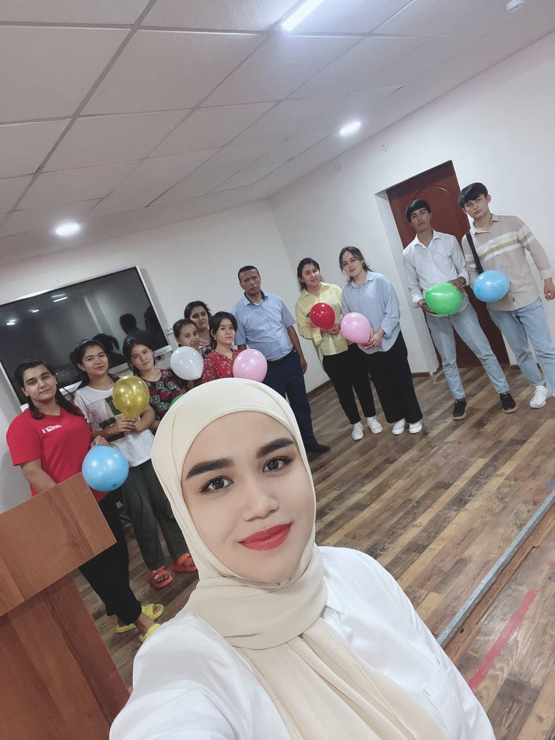
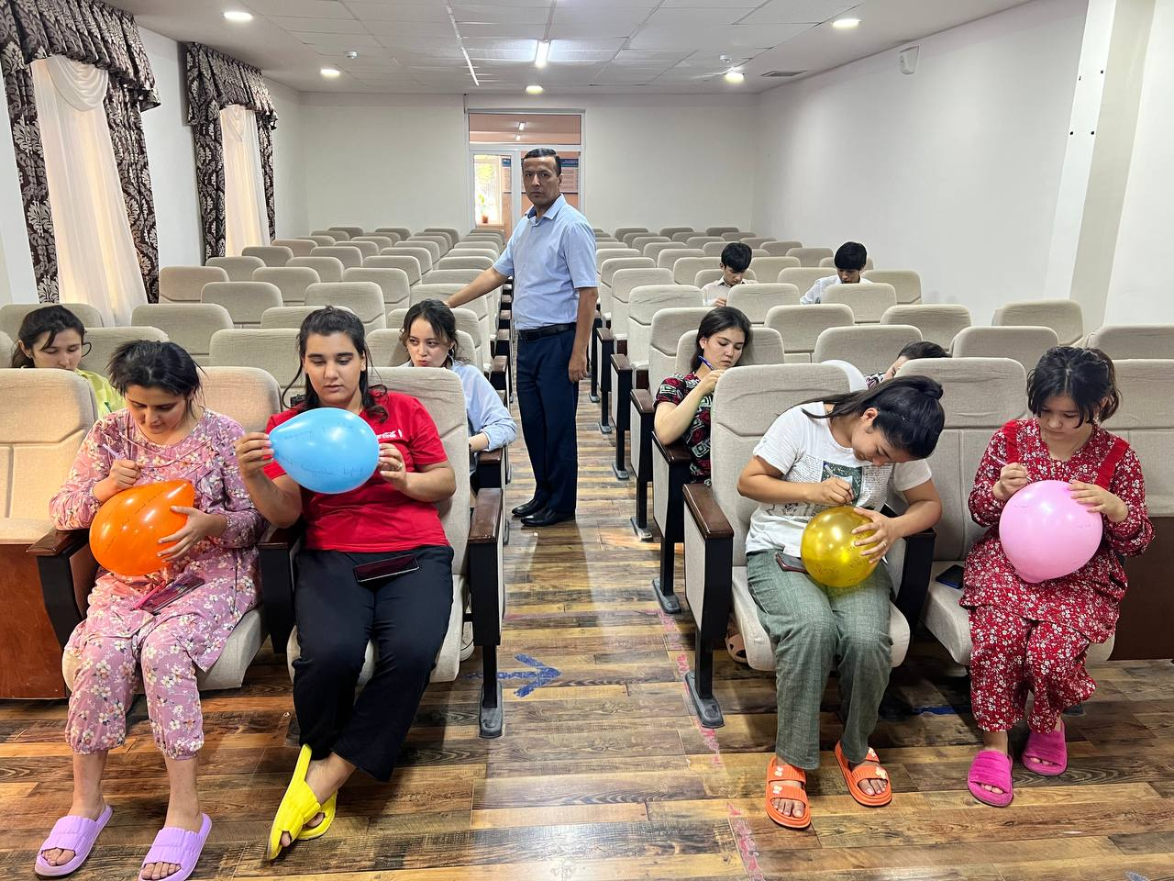
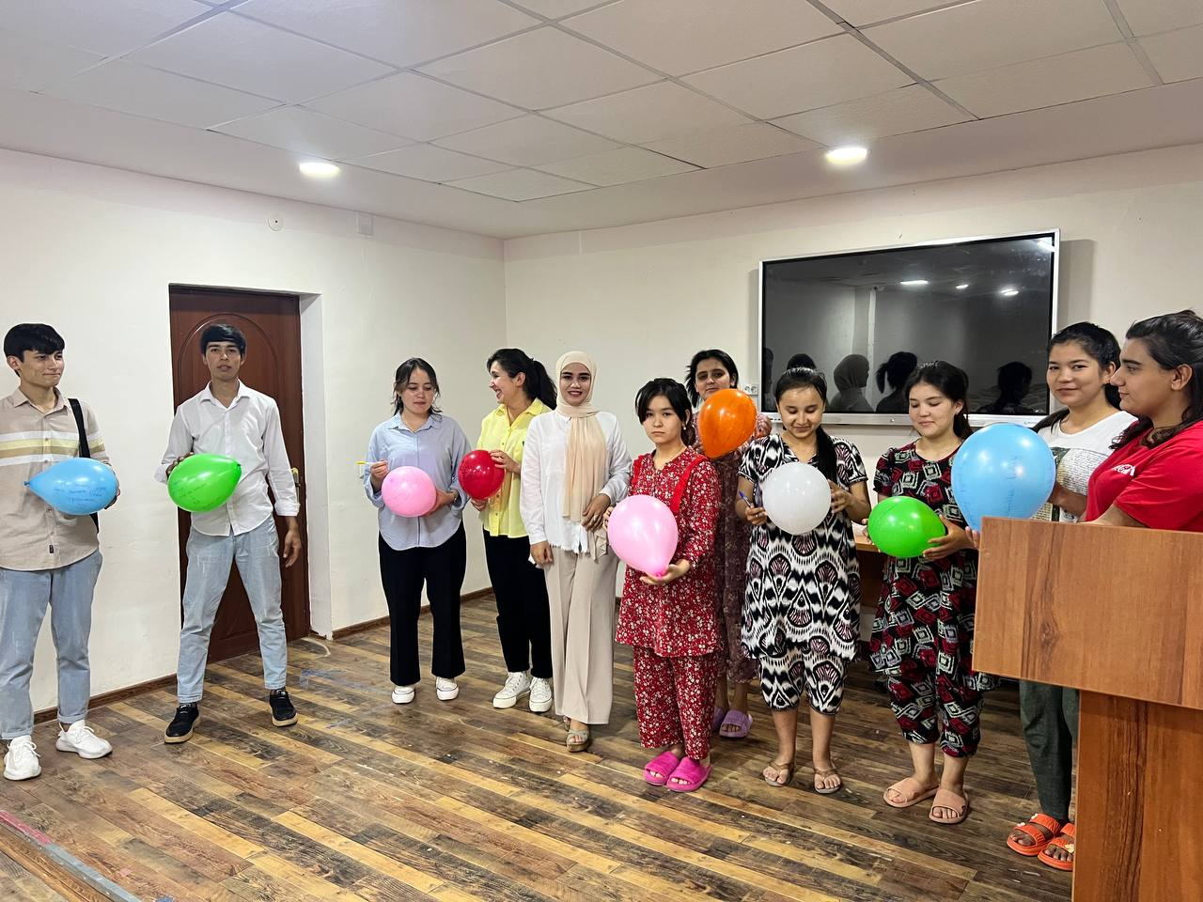
“Xorijiy Tillar” kafedrasi  professor- o‘qituvchilari: |  | F.T.Sayfullayeva  T.B. Maxkamov  Sh.Sh.Murtazoyeva  Z.Djumanazarova  Yuldoshev.B  U.T.Djalilova

Minutes of a round interview held by teachers of the "Foreign Languages" department of TICT, MPE faculty in the student dormitory

26.05.2023 Tashkent city

PARTICIPANTS: | teachers of the "Foreign Languages" department and students of dormitory

AGENDA:
State symbols of the Republic of Uzbekistan
To study the living conditions of the students in dormitory
The teacher of the department of foreign languages F.T.Saifullayeva spoke about the symbols of our country and the fact that the flag of our country is always reflected in the achievements of our youth and interesting activities were conducted by the teachers of the department and they wished the young people of Uzbekistan good luck and joy in their future achievements and advancement.
During this day, the teachers of the "Foreign Languages" department of the MPE Faculty observed the living conditions of the students and studied their suggestions.
A roundtable discussion was held on raising the morale of young people and meaningful organization of their free time.
Qualified personnel are a great force that determines the future development of the country. Today, the world's leading countries are paying special attention to the education of educated, potential youth. It's not in vain. After all, in the process of socio-economic and political reforms, any country needs well-educated, intelligent, well-rounded national personnel at the level of world standards.
Student residences were checked one by one and given advice. It was mentioned that they should clean the rooms and preserve the given conditions and leave them clean for the students of the next academic year.
Each floor of the dormitory was inspected one by one. Their kitchen, washrooms, rest rooms and study rooms were checked. It was said that it will help students to become members of the library and read more books and improve their level of knowledge and fluency in speaking.

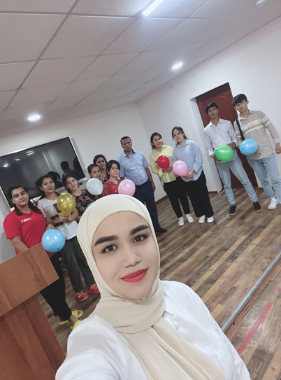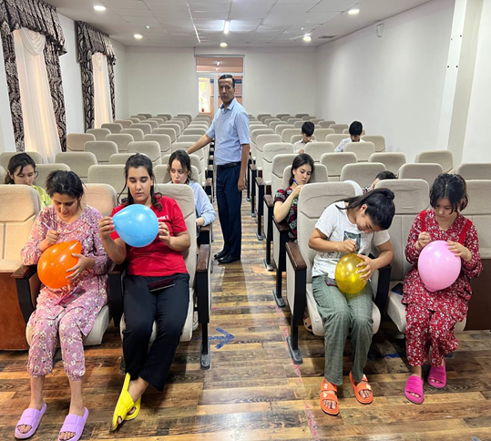
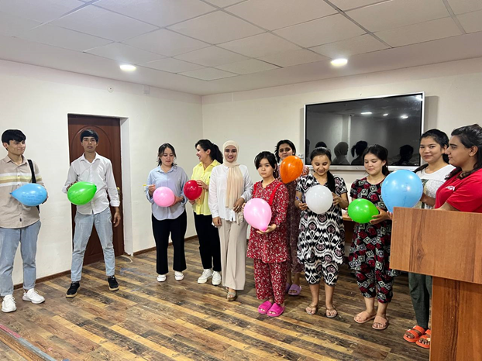

Teachers of the "Foreign  Languages" department: | F.T.Sayfullayeva  T.B. Maxkamov  Sh.Sh.Murtazoyeva  Z.Djumanazarova  Yuldoshev.B  U.T.Djalilova

