Toshkent kimyo-texnologiya INSTITUTI MENEJMENT VA KASB TA’LIMI FAKULTETIDA “Ingliz tili” dan o`tkazilgan
“I Yoshlar olimpiadasi” BAYONNOMASI

Toshkent shahri 15.02/2023 - 30.03.2023y.

Rais: TKTI Menejment va Kasb Ta’limi Fakultetining Xorijiy Tillar kafedrasi mudiri K.D. Davlatov

Tashkilotchilar:
O’zbekiston Yoshlar Ittifoqining Toshkent Kimyo-Texnologiya Instituti Markaziy Tashkiloti;
TKTI Menejment va Kasb Ta’limi Fakulteti, Xorijiy Tillar kafedrasi assitent o’qituvchilari B.Yuldoshev, Sh.Murtazoyeva, F.Sayfullayeva

Kotiba: Menejment va Kasb Ta’limi Fakulteti, Xorijiy Tillar kafedrasi assitent o’qituvchisi Sh.Murtazoyeva.

KUN TARTIBI: Ingliz tilidan oʻtkazilgan “Yoshlar olimpiadasi” natijalari
toʻgʻrisida.

ESHITILDI: Olimpiadani “Menejment va Kasb Ta’limi” fakulteti dekani muovini A.Abdulakimov, “Xorijiy Tillar” kafedrasi mudiri K.D.Davlatov hamda O`zbekiston yoshlar ittifoqi IBT yetakchisi Azizjon Adhamovlar ochib berishdi. Kafedrada faoliyat yurgizib kelayotgan assistant o’qituvchilar Bobir Yuldoshev hamda Shodiya Murtazoyeva olimpiada tartib qoidalari, bosqichlari haqida tegishli ma`lumotlar berdi.
SO’ZGA CHIQDILAR: Ingliz tilidan o`tkazilgan “Yoshlar olimpiadasi” natijalari bo‘yicha ma’lumot berish uchun so‘zni, “Xorijiy Tillar” kafedrasi mudiri K.D.Davlatovga berildi.
K.D.Davlatov so‘zga chiqib, fizika fanidan olimpiada 10 nafar institut talabalari qatnashganligini ta`kidladi.
Olimpiada 1 bosqichda o`tkazilib, joriy yilning 25-fevral kuni soat 15:00 da bo`lib o`tdi. O‘tkazilgan olimpiadada ro`yxatdan o`tgan talabalarning umumiy soni 20 nafarni, qatnashganlar soni esa 10 nafarni tashkil qildi. Olimpiada ishtirokchilarga ingliz tilidagi asosiy 4 ta malaka ya’ni o’qish, tinglash, gapirish va yozish ko’nikmalari bo’yicha tuzib chiqilgan savollar taqdim etildi hamda 2 soat vaqt ajratildi. Ingliz tilidan taqdim etilgan olimpiada topshiriqlari maksimal 100 ball bilan baholandi. O’qish ko’nikmasi yuzasidan tuzilgan savollar uchun maksimal 25 ball, tinglash malakasi yuzasidan tuzilgan savollarga maksimal 25 ball, gapirish va yozish ko’nikmalari bo’yicha tuzilgan savollarga ham maksimal 25 ball qo’yilishi belgilandi.
Ushbu fan olimpiadasidagi tanlov shartlarini qatnashuvchilar tomonidan bajarilgan ishlari kafedra mudiri rahbarligida va tayinlangan masʼullar hay’ati tomonidan belgilangan mezonlar asosida baholanib, natijalar bo`yicha ishtirokchilarning egallagan o`rinlari ko`rsatildi.

Qaror qilindi: Quyidagi talabalar Ingliz tilidan “I Yoshlar olimpiadasi” da faxrli o‘ringa munosib deb topildi:
I o‘rin – MKTF B21 – 02u – TM4 guruh talabasi Sodiqov Jonibek Soliq o`g`li – 80ball.
II o‘rin – YOBKT fakulteti 22-18 guruhi talabasi To`ymurodov Diyorbek Orifjonovich – 60 ball.
III o‘rin –NMKT fakulteti B21 – 02u – TM1 guruhi talabasi Abdullayev Bahodir Botir o’g’li – 58 ball

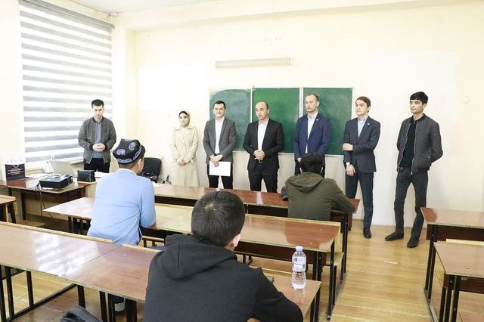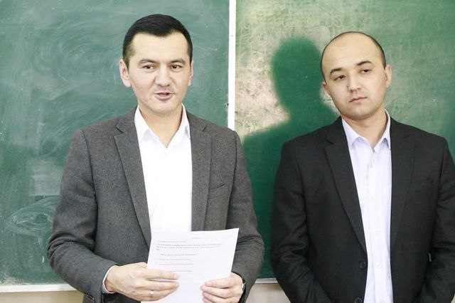

Rais: K.D.Davlatov
O’qituvchilar: Sh.Murtazoyeva
B.Yuldoshev
F.Sayfullayeva
MINUTES OF THE YOUTH OLYMPIAD ON "ENGLISH LANGUAGE" AT THE FACULTY OF MANAGEMENT AND PROFESSIONAL EDUCATION OF THE TASHKENT INSTITUTE OF CHEMICAL TECHNOLOGY
Tashkent city 15.02.2023 – 30.03.2023
Chairman: Davlatov K.D., Head of the Department of “Foreign Languages” of the Faculty “Management and Professional Education” of the TICT
Organizers:
Tashkent Institute of Chemical Technology Central Organization of the Youth Union of Uzbekistan;
TKTI, Faculty of Management and Professional Education, assistant teachers of the Department of Foreign Languages B. Yuldoshev, Sh. Murtazoyeva, F. Sayfullayeva
Secretary: Assistant teacher Sh. Murtazoyeva, Department of Foreign Languages, Faculty of Management and Professional Education.
Agenda: About the results of the "Youth Olympiad" held in “English language”.

Listened: | The Olympiad was opened by A. Abdulakimov, the deputy dean of the "Management and Vocational Education" faculty, K.D. Davlatov, the head of the "Foreign Languages" department, and Azizjon Adhamov, the leader of the Youth Union of Uzbekistan. Bobir Yuldashev and Shodiya Murtazoyeva, assistant teachers working in the department, gave relevant information about the rules and stages of the Olympiad.

Speech: | The head of the "Foreign Languages" department, K.D. Davlatov, informed about the results of the "Youth Olympiad" held in English. He also noted that 10 students of the institute participated in the Physics Olympiad.

The Olympiad was held in one stage and took place on February 25 of this year at 3: 00 pm. The total number of registered students in the Olympiad was 20, and the number of participants was 10. Olympiad participants were presented with structured questions on the 4 main skills of the English language, i.e. reading, listening, speaking and writing skills, and 2 hours were allocated. Olympiad tasks presented in English were evaluated with a maximum of 100 points. A maximum of 25 points will be assigned to questions on reading skills, a maximum of 25 points to questions on listening skills, and a maximum of 25 points to questions on speaking and writing skills.
The work performed by the participants of this Science Olympiad was evaluated under the guidance of the head of the department and on the basis of the criteria established by the board of officials, and the places occupied by the participants were shown according to the results.
The decision was made: At the "Ist Youth Olympiad" in English, the following students were recognized as worthy of honor:
1st place - Sodikov Zhonibek, a student of the group B21 - 02u of MPEF - 80 points.
2nd place - Toymurodov Dyorbek Orifzhonovich, student of the 22-18th group of the faculty CTHMS - 60 points.
3rd place - Abdullaev Bahadir, student of the group B21 - 02u TM1 of the faculty CTIS - 58 points
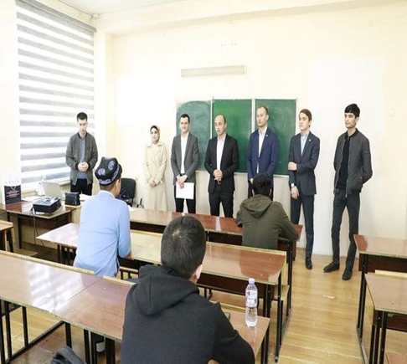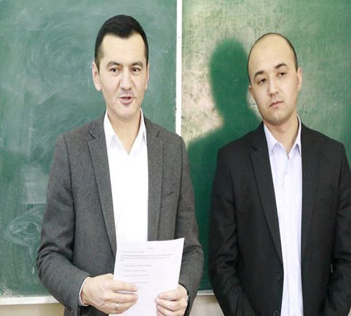

Chairman: K.D.Davlatov
Teachers: Sh.Murtazoyeva
B.Yuldoshev
F.Sayfullayeva

