**Documents related to the activities of the department**

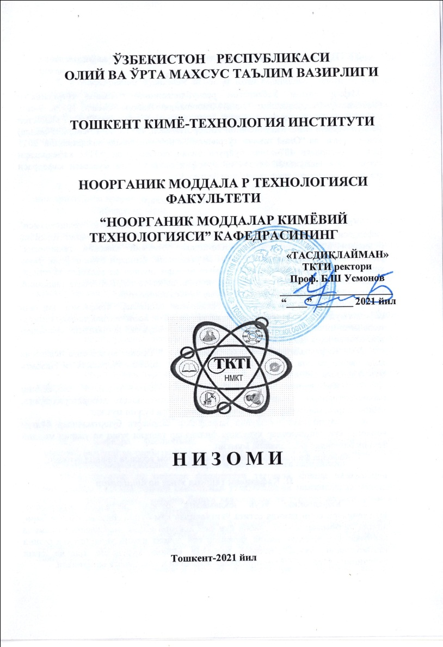

**Educational literature**

|  |  |  |
| --- | --- | --- |
|  |  | Описание: C:\Users\user\AppData\Local\Microsoft\Windows\Temporary Internet Files\Content.Word\im11893.jpg |

**Research activities**

The scientific-research works carried out in the department are aimed at finding solutions to the problems of the chemical industry, oil and gas and other similar production enterprises by studying their chemical basis.

**Research work carried out on the basis of the State program at the department in the 2022-2023 academic year**

|  |  |  |  |
| --- | --- | --- | --- |
| **№** | **Scientific directions of the department** | **Project manager** | **Professors and teachers participating in the scientific project** |
| 1. | №AM-FZ-2019081644  Development of technology for phosphorus and nitrogen-phosphorus mineral feed additives for the fish industry as an alternative to ammophos | Doctor of technical sciences, prof. Mirzakulov Kh.Ch. | Melikulova G.E.  Khuzhamberdiev Sh.M.  Shaimardonova M.A. |
| 2. | Development of technology for continuous production of chlorine-free potassium-containing fertilizers for growing agricultural products | Doctor of Technical Sciences, prof.,  Erkaev A.U. | Toirov Z.K.  Dzhandullaeva M.S.  Adilova M.Sh.  Sharipova H.T  Turakulov B.B. |