TKTI MKT FAKULTETI “XORIJIY TILLAR” KAFEDRASI PROFESSOR O‘QITUVCHILARI VA EVEREST O‘QUV MARKAZ TOMONIDAN O‘TKAZILGAN DAVRA SUHBAT
B A YO N N O M A S I

18.11.2022 Toshkent shahri
QATNAShDILAR: “Xorijiy Tillar” kafedrasi professor -o‘qituvchilari va talaba yoshlar
KUN TARTIBI Ilm dargohining iqtidorli talabalari bilan ochiq suhbat

M va KT fakulteti “Xorijiy tillar” kafedrasi, professor -o‘qituvchilari tashabbusi bilan 26-Oktabr, kuni A.Navoiy,32 Faollar zalida ilm dargohining iqtidorli talabalari bilan ochiq suhbat bo’lib o’tdi.
Ilm maskanlarini ochayotgan nodavlat taʼlim maskani, o'quv kurslarining oldi yetakchi maqomini qoʻldan bermay kelayotgan, borgan sari ziyo qanoatini keng yoyayotgan EVEREST oʻquv markazi asoschisi Xurshidjon Oʻroqov bilan “Hozirgi kunda xorijiy tillarning oʻrni” mavzusida talaba yoshlar oʻrtasida uchrashuvoʻtkazildi.
Uchrashuv juda koʻtarinki va ochiq doʻstona ruhiyatda olib borildi. Xurshid Oʻroqov talaba-yoshlarning IELTS imtihoni va til oʻrganishning eng qulay yoʻllari, kurs tomonidan til oʻrganuvchilariga beriladigan chegirmalar va kursning Xorijiy tillar kafedrasi qoshida ochilayotgan GLOBAL LANGUAGE oʻquv markazi afzalliklari haqidagi savollariga javob berdi.
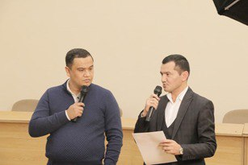
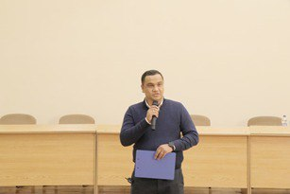
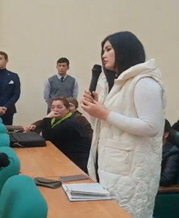
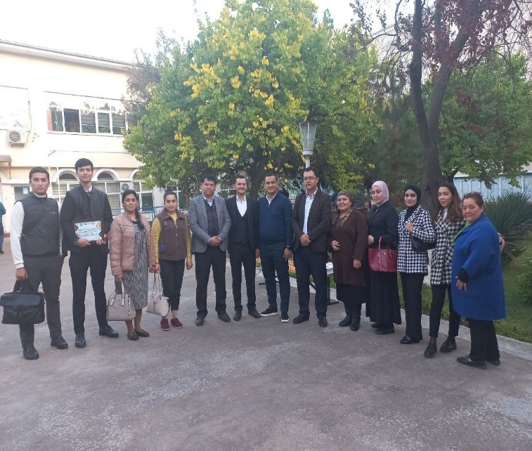
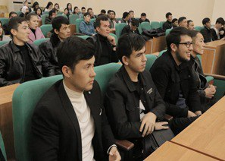
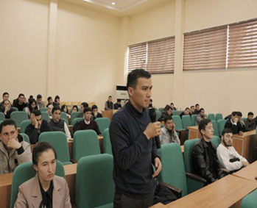

“Xorijiy tillar” kafedrasi
professor-o‘qituvchilar K.D. Davlatov
M.M.Shokirova
M.R. Djumaniyozova
G.U.Komilova
M.B.Ostonova
U.T.Djalilova
N.B.Abdullayev
T.B. Maxkamov
F.Sayfullaeva
Z. Djumanazarova

A CIRCULAR CONVERSATION HELD BY PROFESSIONAL TEACHERS OF THE DEPARTMENT OF "FOREIGN LANGUAGES" OF THE FACULTY OF MKT OF TKTI AND THE EVEREST EDUCATIONAL CENTER

STATEMENT
18.11.2022 Tashkent city
PARTICIPANTS: professors and teachers of the "Foreign Languages" department and young students
AGENDA: An open conversation with talented students of the Institute
On October 26, on the initiative of the "Foreign Languages" department, faculty of M and CT, an open conversation was held with the talented students of the department of science in the hall of A.Navoi, 32.
A meeting was held between students and young people on the topic "The role of foreign languages ​​today" with the founder of the EVEREST educational center, which is a non-state educational center that is opening centers of knowledge, and is not losing its leading status in front of educational courses, and is increasingly spreading the satisfaction of intellectuals.
The meeting was conducted in a very cheerful and open friendly spirit. Khurshid Orokov answered students' questions about the IELTS exam and the most convenient ways to learn the language, discounts given by the course to language learners, and the advantages of the GLOBAL LANGUAGE training center, which is being opened under the Department of Foreign Languages.

Professors and teachers of "Foreign Languages" department:
K.D. Davlatov
M.M.Shokirova
M.R. Djumaniyozova
G.U.Komilova
M.B.Ostonova
U.T.Djalilova
N.B.Abdullayev
T.B. Maxkamov
F.Sayfullaeva
Z. Djumanazarova

