TKTI MKTF fakulteti “Xorijiy Tillar” kafedrasi o‘qituvchilari NMKTF 22-15-guruh talabalari bilan birgalikda Yangi O’zbekiston bog’iga tashrif buyurdilar

Qatnashdilar:
“Xorijiy Tillar” kafedrasi o‘qituvchilari Murtozoeva Shodiya
Jo’rayeva Gulnoza
22-64- guruh talabalari

08.05.2023 Toshkent shahri

KUN TARTIBI:

Talabalarga xorijiy tillarni roli va uning kelajakdagi ahamiyatini tushuntirish

08-may kuni Xorijiy tillar kafedrasi o’qituvchisi Murtozoeva Shodiya va kafedra assistenti Umida Djalilova "Noorganik moddalar kimyoviy texnologiyasi” fakulteti 22-15 guruh talabalari bilan birgalikda 9-May — Xotira va Qadrlash Kuni munosabati bilan Toshkent shahrida joylashgan Yangi O’zbekiston bog’iga tashrif buyurishdi. Tashrif davomida talabalarga O‘zbekiston xalqining Ikkinchi jahon urushi davrida ko‘rsatgan jasorati, bukilmas irodasi va matonati, insonparvarlik fazilatlari haqida so’z yuritildi. Bugungi tinch va osoyishta, erkin va farovon hayot uchun aziz jonini fido qilgan ajdodlarimizning yorqin xotirasini yod etilib, ularga ezgu ishlarini munosib davom ettirish — tinchlikni buyuk ne’mat deb biladigan bag‘rikeng va olijanob xalqimizga munosib farzand bo’lib ulg’ayishlari va vatanimiz kelajagi uchun o’z hissalarini qo’shishlari masuliyati haqida suhbat olib borildi.



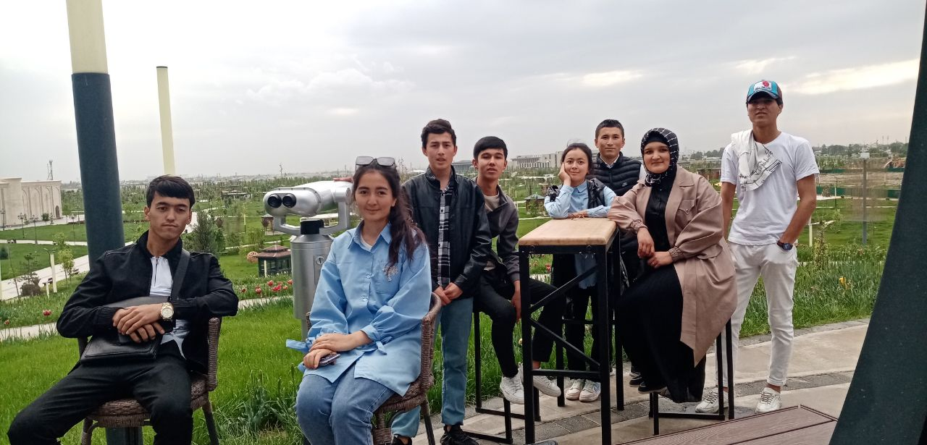

“Xorijiy Tillar” kafedrasi o‘qituvchilari Sh. Murtozoeva
G. Jo’rayeva

Teachers of the "Foreign Languages" department of MPE faculty, TICT together with the students of group 22-15 of the faculty CTIS visited New Uzbekistan Park
Attended:
The teachers of the "Foreign Languages" department | Murtozoeva Shodiya Jorayeva Gulnoza  Students of group 22-64
08.05.2023 Tashkent city
AGENDA:
To explain to the students the role of foreign languages and their future importance
On May 8, the teachers of the Department of Foreign Languages Murtozoeva Shodiya and the assistant of the department Jorayeva Gulnoza together with the students of group 22-15 of the faculty "Chemical Technology of Inorganic Substances" visited the New Uzbekistan Park in Tashkent on the occasion of May 9 - Day of Remembrance and Honor. The bright memory of our ancestors, who sacrificed their lives for today's calm and peaceful, free and prosperous life, was commemorated, and a conversation was held about the responsibility of them to continue their noble deeds, to grow up as worthy children of our tolerant and noble people, who consider peace as a great blessing, and to contribute to the future of our country.

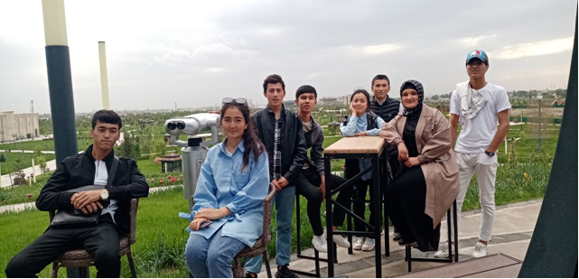

Teachers of the "Foreign Languages" department | Sh. Murtozoeva  G. Jorayeva

