Toshkent kimyo-texnologiya instituti Menejment va kasb ta'lim fakulteti “Xorijiy tillar" kafedrasi professor-o’qituvchilarining
Toshkent kimyo-texnologiya instituti qoshidagi akademik litsey
o'quvchi yoshlari bilan uchrashuvi
BAYONNOMASI

Toshkent shahri 31.05.2023

QATNASHDILAR: Akademik litsey direktor o'rinbosari F.Sadikov, xorijiy filologiya kafedrasi mudiri F.Axmedova, TKTI ning “Xorijiy tillar” kafedrasi professor-o’qituvchilari va litseyning ingliz tili fan o'qituvchilari.
KUN TARTIBI: Toshkent shahri TKTI qoshidagi akademik litsey direktori o'rinbosari F.Sadikov o’quvchilarga TKTI “Xorijiy tillar” kafedrasi professor - o'qituvchilarini tanishtirdi. OTMga kirish uchun yoshlar o'rtasida kasbga yo'naltirish ishlari olib borish "Xorijiy tillar" kafedrasi mudiri K.D.Davlatov so’z boshlab, institutdagi fakultetlar va fakultatetda mavjud yo'nalishlar, yangi tashkil etilgan yo'nalishlar, o'qitiladigan fanlar, instituting ta'lim sohasida qaysi davlatlar bilan hamkorlik tuzganligi va shu davlatlarning oliy ta'lim maskanlarida o'qish imkoniyati borligi, qo'shma dastusrlar ya'ni ikki diplomli mutaxassis bo'lishlari va kelajakda yetuk, o'ziga ishongan yuqori bilimli mutaxassis bo'lib yetishishlari va talabalar o'qishlari uchun yaratilgan shart-sharoitlar yetarli darajada ekanligi haqida litsey o'quvchilariga umumiy ma'lumot berdi. Shuningdek, uchrashuv davomida asosan yoshlarning bilim saviyasi, qiziqishlari va intilishlaridan kelib chiqqan holda foydali va qiziqarli ma'lumotlar bilan tanishtirildi. Assistent o'qituvchi Sh. Murtazaeva o'quvchilarning o'zlari uchun qiziq bo'lgan barcha yo'nalishlari, shu jumladan, qaysi fandan test bo'lishi va o'tgan yil kirish ballari haqidagi ma'lumotlar bo'yicha savollariga javob berdi. Shu bilan birgalikda o’quvchilarga qo’shimcha ta’lim to’grisida ma’lumotlar berildi.
Uchrashuv so'nggida litsey o'quvchilari o'z fikr-mulohazalaini bildirishib, TKTI professor-o'qituvchilari jamoasiga mazmunli suhbat uchun minnatdorchilik bildirishdi. Litsey o'quvchilariga o'qishlarida va kelajakdagi rejalarida ulkan zafarlar tilashdi. Uchrashuv yoshlarimiz uchun ma'lumotlarga boy va mazmunli bo'ldi.
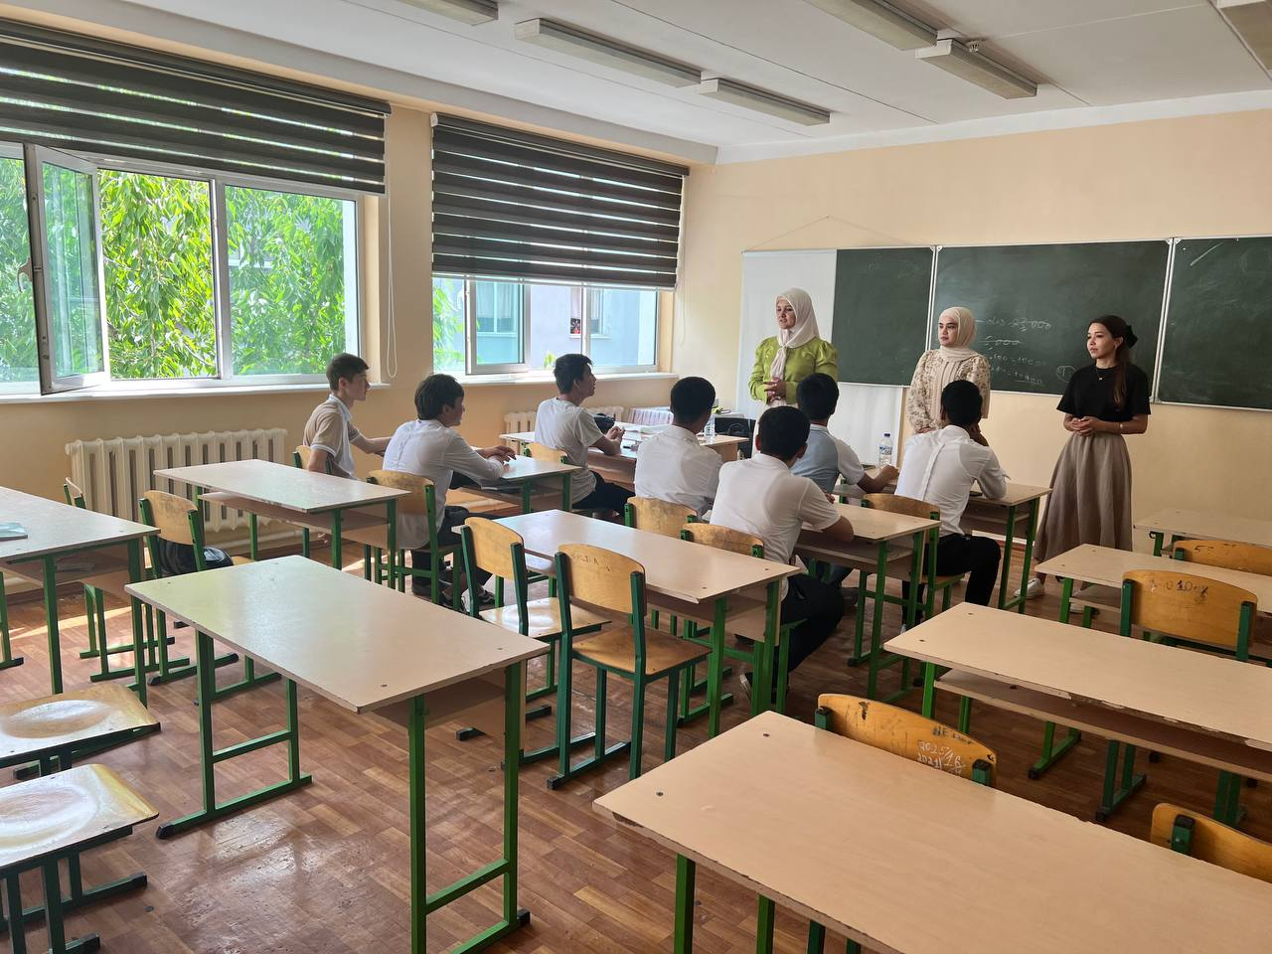
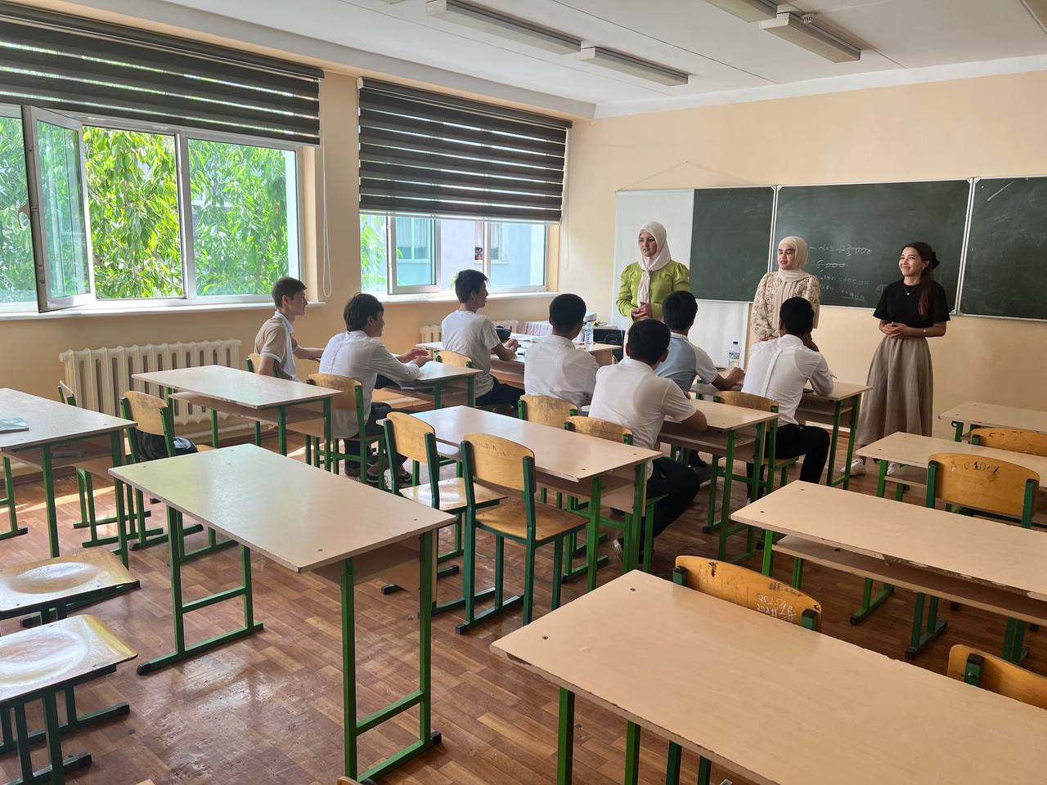
AL O'IBDO: F.G. Sadikov
Tillar kafedrasi mudiri F.Axmedova
"Xorijiy tillar" kafedrasi mudiri : K.D. Davlatov

O'qituvchilar:
Djumanazarova Z.
Sayfullaeva F.
Murtazaeva Sh.

Meeting with Professors and teachers of the "Foreign Languages" Department of the Faculty of Management and Vocational Education of Tashkent Chemical Technological
Institute and students of
Academic Lyceum at Tashkent Chemical Technological
Institute

STATEMENT
Tashkent city 31.05.2023
PARTICIPANTS: Academic lyceum deputy director F. Sadikov, foreign philology department head F. Akhmedova, professors and teachers of the "Foreign Languages" department of TKTI and English language teachers of the lyceum.
AGENDA: F.Sadikov, the deputy director of the academic lyceum under Tashkent city TKTI, introduced the professors and teachers of the "Foreign languages" department of TKTI to the students. K.D. Davlatov, head of the "Foreign Languages" department, made a speech and spoke about the faculties of the institute, newly established departments, taught subjects, which countries the institute has cooperated with in the field of education, and the possibility of studying in higher education institutions of these countries, joint programs, i.e. becoming specialists with two diplomas, and in the future gave general information to the students of the lyceum that they can become self-confident highly educated specialists and that the conditions created for students' studies are sufficient. Moreover, during the meeting, useful and interesting information was introduced based on the level of knowledge, interests and aspirations of young people. Assistant teacher Sh. Murtazaeva answered the students' questions about all areas of interest to them, including the subject of the test and information about last year's entrance scores. At the same time, students were given information about additional education. At the end of the meeting, the students of the Lyceum expressed their opinion and thanked the team of professors and teachers of TKTI for the meaningful conversation. They wished the Lyceum students great success in their studies and future plans. The meeting was rich in information and meaningful for our young people.
AL O'IBDO: F.G. Sadikov
Head of the department of languages F. Akhmedova
Head of the "Foreign Languages" department: K.D. Davlatov

Teachers:
Djumanazarova Z.
Sayfullaeva F.
Murtazaeva Sh.

