Toshkent kimyo-texnologiya instituti Menejment va kasb ta'lim fakulteti “Xorijiy tillar" kafedrasi professor-o’qituvchilarining
Toshkent kimyo-texnologiya instituti qoshidagi akademik litseyda o’tkazilgan YaDa nazoratchisi sifatida ishtiroki
BAYONNOMASI

Toshkent shahri 15.06.2023

QATNASHDILAR:
Akademik litsey direktor o'rinbosari F.Sadikov
Xorijiy filologiya kafedrasi mudiri F.Axmedova,
TKTI “Xorijiy tillar” kafedrasi professor-o’qituvchilari: Murtozoeva Shodiya
Sayfullayeva Fayozaxon
Djumaniyazova Ziyada

Litseyning ingliz tili fan o'qituvchisi B.Z. Nuriddinov
Imtihon jarayoni Toshkent shahri TKTI qoshidagi akademik litseyda ingliz tili fanidan o’tkazilgan yakuniy davlat attestatsiyasi akademik litsey direktori o'rinbosari F.Sadikov, ingliz tili fani o’qituvchisi, TKTI “Xorijiy tillar” kafedrasi professor-o’qituvchilari: Sh. Murtozoeva, F. Sayfullayeva, Z. Djumaniyazova nazoratida o’quvchilarga omad tilagan holda ochib berildi va imtihon olib borilish tartibi tushuntirildi.
Har bir o’quvchi variantlardan tanlab olib nazoratchi o’qituvchilarga o’z belit raqamlarini va og’zaki savollarini yozdirib o’z joylarini egallashdi va o’quchilarga tayyorgarlik uchun 15 minut vaqt berildi. Belit savollari 3 qisimdan iborat etib belgilangan edi; og’zaki(speaking), o’qish (reading), gramatika.
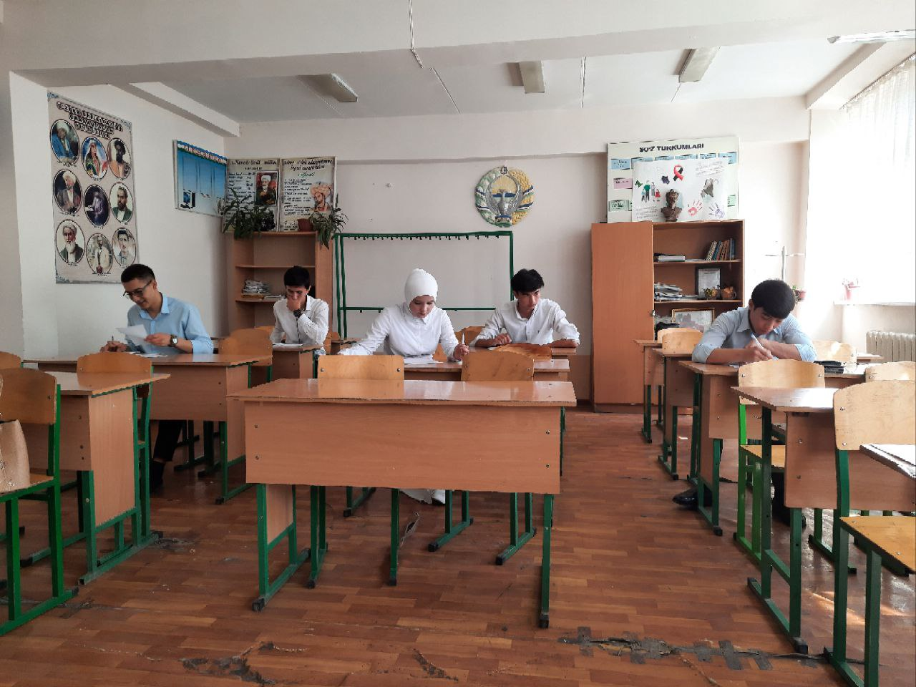
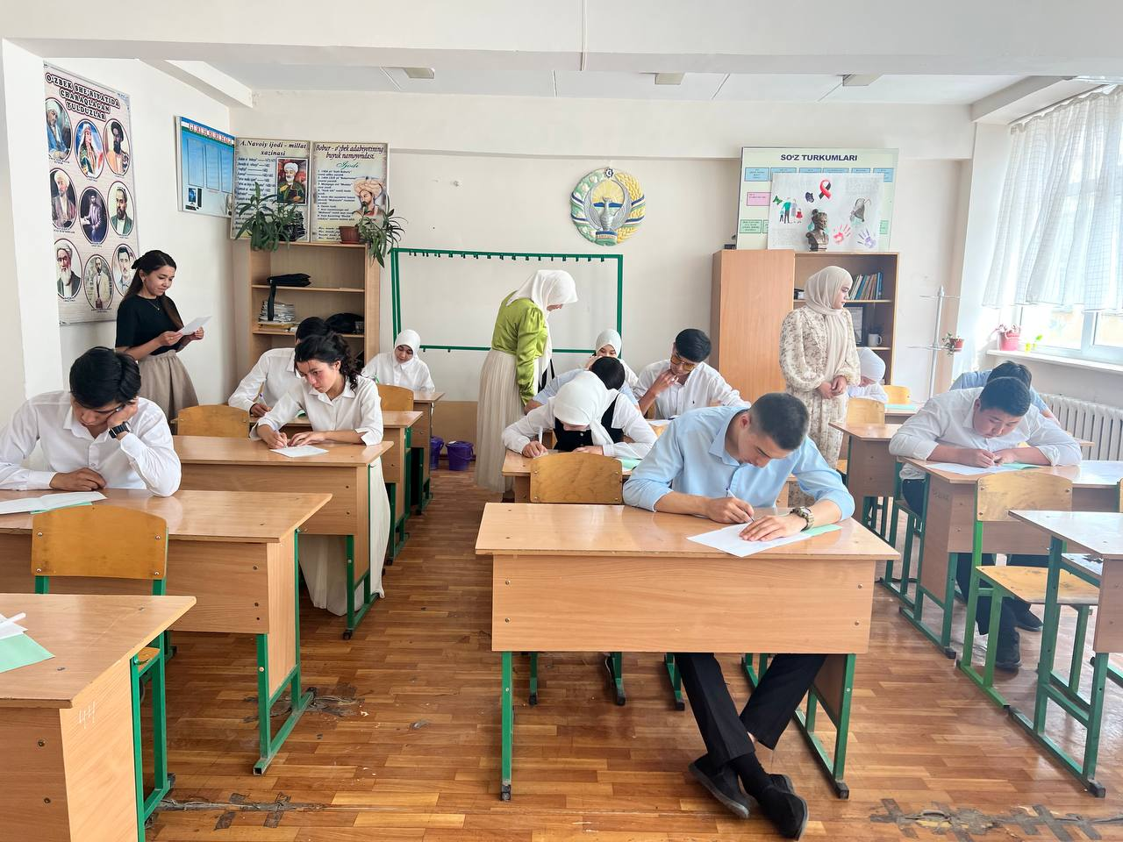
Javob berish jarayonida qiynalgan o’quvchilarga yingillik yaratish maqsadida nazoratchi o’qituvchilar savollarni osonroq savollar bilan o’zgartirildi. Har bir o’quchi shafof baholandi.

O’quvchilarga keyingi imtihonlarida, va maqsad qilingan Institut va Universitelarga kirish imtihoniga zafarlar tilagan holda yakuniy davlat attestatsiyasi tugalandi.
AL O'IBDO: F.G. Sadikov
Tillar kafedrasi mudiri F.Axmedova
Akademik litsey o’qituvchisi B.Z. Nuriddinov
"Xorijiy tillar" kafedrasi mudiri: K.D. Davlatov

"Xorijiy tillar" kafedrasi o'qituvchilar:
Djumanazarova Z.
Sayfullaeva F.
Murtazaeva Sh.

Professors and teachers of the "Foreign Languages" Department of the Faculty of Management and Vocational Education of the Tashkent Institute of Chemical Technology
Participation as a supervisor in the academic lyceum at the Tashkent Institute of Chemical Technology
Tashkent city 15.06.2023
ATTENDED:
Academic lyceum deputy director F. Sadikov
Head of the Department of Foreign Philology F. Akhmedova,
Professors-teachers of the "Foreign Languages" department of TKTI: Murtozoeva Shodiya Sayfullayeva Fayozakhan
Djumaniyazova Ziyada
Lyceum English teacher B.Z. Nuriddinov
Examination process Final state attestation of the English language at the academic lyceum under TKTI of Tashkent city, deputy director of the academic lyceum F. Sadikov, teacher of English, TKTI "Foreign Languages" department professors: Sh. Under the supervision of Murtozoeva, F. Saifullayeva, and Z. Djumaniyazova, students were wished good luck and the procedure of the exam was explained.
Each student chose from the options and wrote their ticket numbers and oral questions to the supervising teachers and took their seats, and the students were given 15 minutes to prepare. Questions were defined as having 3 parts; speaking, reading, grammar.
In order to make it easier for the students who had difficulty in answering the questions, the supervising teachers changed the questions with easier ones. Each student was evaluated transparently.
The final state attestation was completed, wishing the students success in their next exams and entrance exams to the institutes and universities.

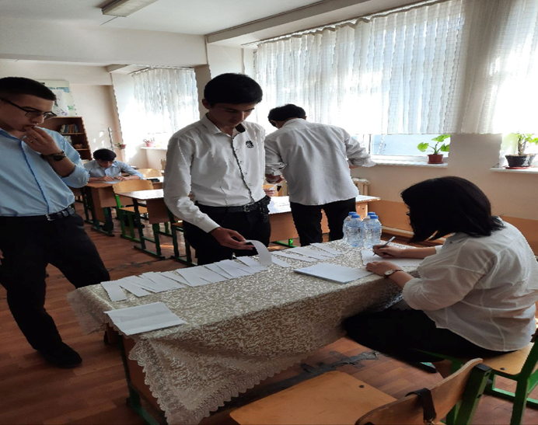

Head of the department K.D. Davlatov
Participants Djumanazarova Z.
Sayfullaeva F.
Murtazaeva Sh.

